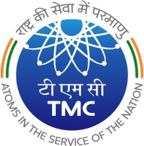
TATA MEMORIAL CENTRE TATA MEMORIAL HOSPITAL
c
(A Grant-in Aid Institute under Dept. of Atomic Energy, Govt. of India)

DR. E. BORGES MARG, PAREL, MUMBAI 400 012

29/05/2023
CPP Portal Tender Notice 5-Corrigendum III

Sub: CPP Portal Tender Notice No. 05 for supply of “Digital PET/CT Scanner Qty: 03 Nos (Qty: 02 Nos for TMH and Qty: 01 No for ACTREC) for Nuclear Medicine Dept, TMH & ACTREC

Please visit CPP Portal web site for details of tender floated for: Digital PET/CT Scanner Qty: 03 Nos (Qty: 02 Nos for TMH and Qty: 01 No for ACTREC) for Nuclear Medicine Dept., TMH & ACTREC

Tender Ref No : TMH/TMC/2022-23/CAP/PT/0060
Tender ID : 2023_TMC_734168_1

Last Date and time of Tender Submission: 05/06/2023 up to 2.00 p.m.

Date and time of opening of Part I Technical Bid: 06/06/2023 at 2.30 p.m. onwards.

Revised specification uploaded on https://eprocure.gov.in/eprocure/app .

PURCHASE OFFICER

